FACTURA 1
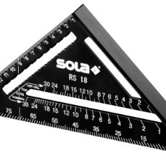 | Echer căpriori multifuncțional din aluminiu, RS 18 - Sola-56160101  Subtotal: 69^{,14} RON  Cantitate: 1 OK
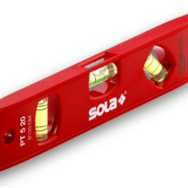 | Nivelă torpedo ( Boloboc ) din plastic PT 5, 20cm - Sola-01430220  Subtotal: 45^{,76} RON  Cantitate: 1 OK
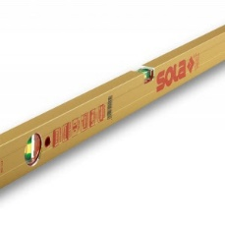 | Nivelă cu bula ( Boloboc ) cu profil tubular, 60cm AZ 60 - Sola-01160801  Subtotal: 155^{,57} RON  Cantitate: 1 OK
Nivelă cu bula ( Boloboc ) cu profil tubular, 200cm AZ 200 - Sola-01161701
Subtotal: 369^{,10} RON
Cantitate: 1 OK
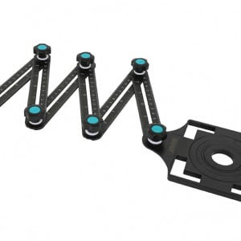 | Localizator reglabil multifunctional pt. gauri in placi - BIHUI-DBG6  Subtotal: 96^{,60} RON  Cantitate: 1 OK
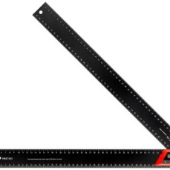 | Echer / goniometru reglabil, WMD 500 - Sola-56052401  Subtotal: 232^{,85} RON  Cantitate: 1 OK
Nivelă cu bula ( Boloboc ) cu profil tubular, 120cm AZ 120 - Sola-01161401
Subtotal: 222^{,68} RON
Cantitate: 1 OK
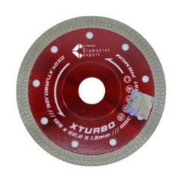 | Disc DiamantatExpert pt. Portelan dur & Gresie ft. dura 125x22.2 (mm) Premium - DXDY.XTURBO.125  Subtotal: 291^{,00} RON  Cantitate: 3 OK
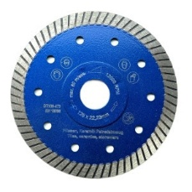 | Disc DiamantatExpert pt. Gresie ft. dura, Portelan dur, Granit - Turbo 125x22.2 (mm) Super Premium - DXDH.3927.125  Subtotal: 547^{,05} RON  Cantitate: 5 OK
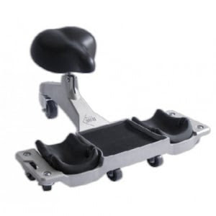 | Scaun ergonomic pt. faiantori si curatenie SR-1 - RUBI-81999  Subtotal: 1.192^{,71} RON  Cantitate: 1 OK
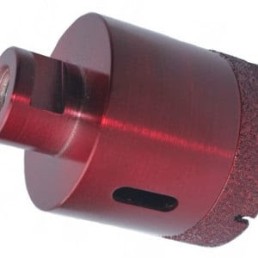 | Carota diamantata pt. gresie portelanata & piatra - diam. 55mm - Premium - DXDH.80408.55  Subtotal: 291^{,62} RON  Cantitate: 1
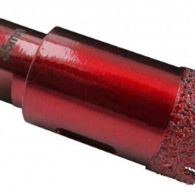 | Carota diamantata pt. gresie portelanata & piatra - diam. 20mm - Premium - DXDH.80408.20  Subtotal: 413^{,64} RON  Cantitate: 3
Carota diamantata pt. gresie portelanata & piatra - diam. 35mm - Premium - DXDH.80408.35
Subtotal: 522^{,84} RON
Cantitate: 3
 | Pe factura va rog SET CAROTE 2 BUC *650 = 1300 LEI

FACTURA 2
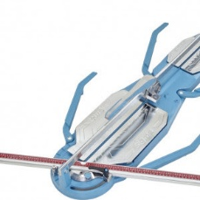 |  | Masina de taiat gresie si faianta 125cm, Serie 4 NEX - Sigma-4EN  Subtotal: 3.323^{,94} RON  Cantitate: 1

FACTURA 3

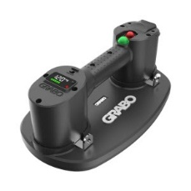 |  | Ventuza Vacuum Electrica Automata cu acumulator Nemo PRO Lifter 20, pt. sticla, gresie, lemn, rigips si alte placi, capacitate max. 170kg - GRABO-GP-1Li-FB-1S  Subtotal: 3.414^{,00} RON  Cantitate: 2

11.724^{,21} RON

